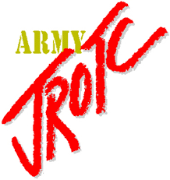
Basic PT Commands
- Fall In!
- The 1st exercise is the Side Straddle Hop
- In Cadence, Exercise
- Position of Attention, Move!
- The next exercise is the Push Up
- Starting Position, Move!

- Side Straddle Hop
- Push Up
- Curls
- Squats
- Run in Place
- Alternate Leg Lift
- Tony Littles
- Alternate Toe Touch
- Mountain Climbers
- The Bird
Stretches (Pg. 8-18)
Over Head Arm Pull (left/right) Rear Lunge (30 seconds)
Upper Back Stretch - Extra Bend & Pull (Left/Right)
Chest Stretch -Extra Single Leg Over
Hurdler Stretch -Extra Extend & Flex
Thigh Stretch
(Pg. 8 ~ 22) PT BOOK

